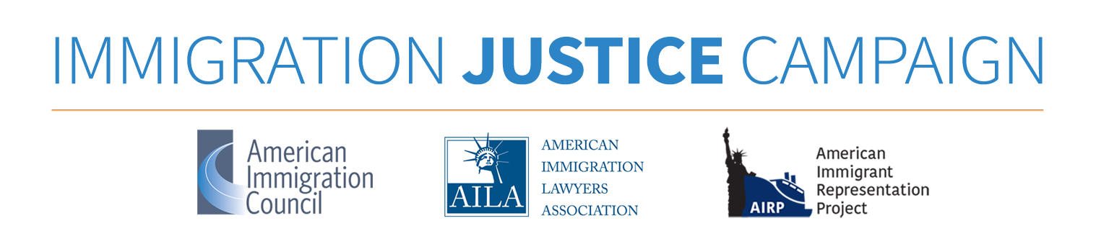

**Was Your Client “Metered” in Mexico?**

***If so, she/he may not be subject to the asylum third country transit bar!***

**What is metering?**

Beginning as early as 2016, the U.S. government began illegally preventing asylum seekers from making direct claims for asylum at ports of entry along the U.S./Mexico border. This practice became official government policy in the spring of 2018, when the Trump administration claimed it had a “lack of capacity” to process asylum seekers and began working with Mexican authorities to limit how many people a day could legally enter the US seeking asylum. Since that time, Customs and Border Protection (CBP) officers have used misrepresentation; threats and intimidation; verbal abuse and physical force; coercion; outright denials of access; and physical obstruction to prevent asylum seekers from accessing U.S. ports of entry. In a process known as “metering,” or illegal turnbacks, CBP officers tell asylum seekers at the border that they must put their names on a waitlist for their turn to request asylum. These waitlists are often maintained by the asylum seekers themselves. As a result of metering, asylum seekers are being forced to wait in dangerous conditions in Mexico for several months just to access a port of entry and present their request for asylum to the U.S. government.

**What is the asylum third country transit bar?**

The asylum third country transit bar, with some exceptions,[1] makes ineligible for asylum most people who entered the United States via the southern land border after July 15, 2019, and who were not formally denied refugee protection in a third country on their way to the United States.

**How does metering impact whether a person is subject to the third country transit bar?**

The American Immigration Council--one of the Campaign’s partner organizations--sued the US government over the illegal turnbacks of asylum seekers. On November 19, 2019, a preliminary injunction was issued prohibiting the government from applying the asylum third country transit bar to non-Mexican[2] asylum seekers who were turned away at the southern border because of the government’s metering policy before July 16, 2019. This means that any asylum seekers who were subject to metering before July 16, 2019 are eligible for asylum, even if they were not able to access a US port of entry until after the transit bar was already in effect.

**How do I know whether my client was metered?**

If your client entered the U.S. at the Southern border after July 15, 2019, you should ask her/him detailed questions about when and how they arrived at the U.S. border. You should ask them when they arrived at the US border, and whether they tried to ask for asylum at a port of entry and were initially denied or told to wait. You should inquire whether they were required to put their names on a wait list in order to present themselves to CBP at a port of entry. You should also ask them how many day/weeks/months they had to wait in Mexico on this list and whether they remember the date when they first arrived on the border.

**What if my client had to wait in Mexico before entering the U.S. but it doesn’t sound exactly like he was subjected to “metering”?**

There are ways in which people are being turned back from the U.S. border, or otherwise made to wait in Mexico before entering the United States, beyond the metering program. And there is language in the preliminary injunction which arguably extends it to these people. If your client was told by **anyone** (U.S. government officials, shelter workers, even other migrants) that she needed to wait in Mexico before entering the U.S., or if she tried to enter but was turned back (even if she wasn’t told to put her name on a list), you might have an argument that the government should be enjoined from applying the transit bar to her.

**How can I prove my client was subjected to metering prior to July 16, 2019?**

Your client’s credible testimony alone can be sufficient proof that she/he was subject to metering and that the asylum transit bar should not apply to their case. If your client has any other proof of when they arrived at the border (i.e. bus ticket stub, receipts, witness statements, etc.), you should collect those too.

**Who determines who is subject to the asylum transit bar?**

The immigration judge will make a determination about which, if any, bars to asylum the asylum seeker is subject to, including the asylum third country transit bar. Even if an asylum officer concluded that the bar applies to your client during the credible fear interview process, the immigration judge can still make a conclusion to the contrary.

**When do I challenge the application of the asylum transit bar to my client who was metered before July 16, 2019**?

1. Pleadings. At Master Calendar, you will enter pleadings on your client’s behalf. If your client entered the US at a port of entry, there will be an allegation on the Notice to Appear (NTA) regarding the date that your client applied for admission. If your client was metered prior to July 16, 2019, but the NTA lists an application date *after* July 16, 2019, you should deny the allegation relating to the date of entry and tell the Court/DHS the actual date the client first applied for admission.

If your client is otherwise eligible, you should inform the judge that your client will be seeking asylum along with withholding of removal and protection under the Convention Against Torture.

[Here is a link to the preliminary injunction itself.](https://www.americanimmigrationcouncil.org/sites/default/files/litigation_documents/litigation_aol_order_granting_plantiffs_motion_for_professional_class_certification.pdf)

1. If your client has already entered pleadings but has not yet had a hearing. In this case, you may want to amend the pleadings, in light of the Preliminary Injunction and its effect on the relief your client will be eligible for, to reflect the actual date your client first tried to apply for admission. Please talk to your Immigration Justice Campaign mentor if your client is in this situation.

1. In your brief, and at asylum hearing*.* In addition to challenging the application of the asylum transit bar to your client’s case at the master calendar hearing, you should also challenge the application of the bar in your brief. If DHS alleges that the bar does apply, you should also be prepared to argue its applicability in Court.

**Have additional questions?**

The American Immigration Council has issued [this](https://www.americanimmigrationcouncil.org/sites/default/files/other_litigation_documents/challenging_custom_and_border_protections_unlawful_practice_of_turning_away_asylum_seekers_faq.pdf) very useful FAQ. In addition, please contact your Immigration Justice Campaign mentor!

1. To determine whether your client fits within one of the exceptions to the asylum third country transit bar, please review [this](https://immigrationjustice.us/get-trained/asylum/getting-started-overview-of-asylum-law-and-process/overview-third-country-transit-bar/) Immigration Justice Campaign resource.
2. The third country transit bar does not apply to Mexicans.